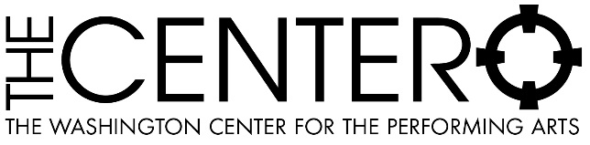
CONTACT:
TINEKE RAAK, MARKETING & SALES DIRECTOR
512 WASHINGTON ST SE OLYMPIA, WA 98501
360-753-8585 ex. 100

THE WASHINGTON CENTER GALLERY
SHOWCASES CASCADIA MOSAIC COLLECTIVE

FOR IMMEDIATE RELEASE

(OLYMPIA, WA, April 29, 2022) The Washington Center Gallery is proud to present the Portals exhibit by Cascadia Mosaic Collective through June 25.

Cascadia Mosaic Collective is a group of Pacific Northwest based artists who practice within and beyond the mosaic tradition. Each with different perspectives and approaches to art making, we are united by a shared sense of place, process and materiality.

Portals is the product of ten Pacific Northwest mosaic artists. Working in stone, glass, ceramic, metal and other hard materials they explore the potential for art to serve as a portal to investigate the past, interrogate the present and imagine the future.

There will be a reception on Saturday, May 14 from 5:00pm – 7:00pm. The Portals exhibit is available to view through June 25 and is open to ticketed patrons before events at the Washington Center, or during the week by appointment. Viewing appointments are available Monday through Friday from Noon to 4:00 pm based on the event schedule at the Washington Center.

Masks are encouraged to be worn at all times while visiting the Washington Center Gallery. Details on the current COVID protocols can be found here: https://www.washingtoncenter.org/events-tickets/plan-your-visit/ . Please E-mail info@washingtoncenter.org or call 360-753-8585 to schedule an appointment.

The Washington Center Gallery has been proud host to many artists and artist’s guilds since the Center’s inception. The space has offered several artists and curators the opportunity to bring visual arts to the community over the years.

The Washington Center for the Performing Arts is a not-for-profit performance venue with a mission to inspire audiences and artists of all ages through live performances, enriching the vibrancy of our community.

For more information please contact:
Tineke Raak, Marketing and Sales Director
marketingdirector@washingtoncenter.org

Box Office Information:
- Box Office hours are Tuesday through Saturday 12:00 pm – 5:30 pm.
- For ticketing questions or more information about upcoming events please visit www.washingtoncenter.org or call the Box Office at 360-753-8586.
- Details on current COVID protocols can be found here: https://www.washingtoncenter.org/events-tickets/plan-your-visit/

2021-2022 Calendar of Events: https://www.washingtoncenter.org/events/month/

###

